1. Write a C program to check whether a given string belongs to the language defined by a Context Free Grammar (CFG)

S → A101A, A → 0A | 1A | ε

AIM :

To write a C program to check whether a string belongs to the grammar S -> A 1 0 1 A A -> 0 A | 1 A | ε Language defined by the Grammar Set of all strings over 𝚺={0,1} having 101 as a substring

ALGORITHM :

1. Get the input string from the user.

2. Find the length of the string.

3. Check whether all the symbols in the input are either 0 or 1. If so, print “String is valid” and go to step 4. Otherwise print “String not valid” and quit the program.

4. Read the input string character by character

5. If the i th input symbol is 1, check whether (i+1) th symbol is 0 and (i+2) th symbol is 1. If so, the string has the substring 101. So print “String Accepted”. Otherwise, print “String Not Accepted”

PROGRAM:

#include<stdio.h>

#include<string.h>

int main()

{

char s[100];

int i,flag,flag1;

int l;

printf("enter a string to check:");

scanf("%s",s);

l=strlen(s);

flag=1;

for(i=0;i<l;i++)

{

if(s[i]!='0' && s[i]!='1')

{

flag=0;

}

}

if(flag==1)

printf("string is Valid\n");

else

printf("string is Not Valid\n");

if(flag==1)

{

flag1=0;

for(i=0;i<l-2;i++)

{

if(s[i]=='1')

{

if(s[i+1]=='0' && s[i+2]=='1')

{

flag1=1;

printf("Substring 101 exists. String accepted\n");

break;

}

}

}

if(flag1==0)

printf("Substring 101 does not exist. String not accepted\n");

}

}

OUTPUT:

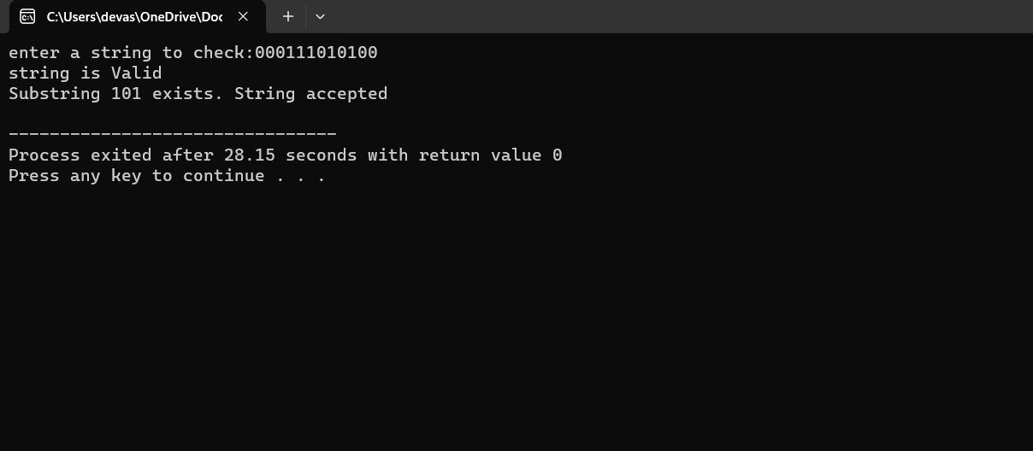

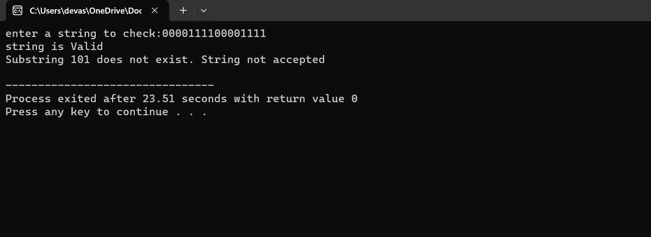

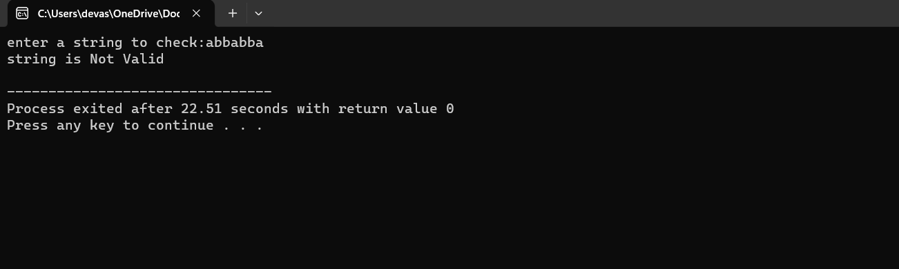

RESULT:

Thus we have successfully executed the language belongs to CFG by using DevC++.